CrossMgrImpinj  
Readme

Edward Sitarski

How to use the CrossMgrImpinj Program with CrossMgr  
  
  
April 2013

Edward Sitarski

edward.sitarski@gmail.com

Contents

Introduction 1

Hardware 1

Impinj Reader 1

Tags and Tag Mounts 2

Antennas and Cables 3

Antenna Stands 4

The “Toolbox” 6

The “Big Box” 10

Hardware Setup at a Race 13

Software and Setup 13

Installation 13

Open the Reader Port in Windows (First time only) 14

Configure CrossMgrImpinj 14

Test with CrossMgr 15

CrossMgrImpinj Readme

How to Use the CrossMgrImpinj Program

# Introduction

Is it true that you can buy a passive RFID reader and antenna for $1500, spend a few hundred more at the home improvement store, and with a little more time and ingenuity, get quality chip timing results just like the pros?

Read on and find out!

This document explains everything about how to make a working and practical system from getting the reader, mounting the tags to publishing the results on the web.

If you want a solution out-of-the-box, by all means, buy a J-Chip system. However, if you are looking to save some money, want passive chips (cheaper), and have the skills to hook up a router and do some home repairs, this project could be for you.

This document explains a CrossMgr-Impinj reader solution created for the Midweek cycling club in Toronto in 2013.

# Hardware

There is a bunch of hardware involved, but none of it too complicated.

Overall the solution is divided into two “boxes”, the Toolbox and the Big box.

The Toolbox is a plastic toolbox that holds all the “computery” stuff (router, power supply, etc.). The Big box holds the reader and cables and does not have live power (more on that later).

For transport, the Toolbox fits into the Big box.

You also need access to a power supply or a generator. If you are using a generator, I also recommend that you invest in a UPS in case you forget to put gas in it.

## Impinj Reader

We selected the Impinj Speedway Revolution reader (see [here](http://www.impinj.com/Speedway_Revolution_UHF_RFID_Reader.aspx)). It looks like this:

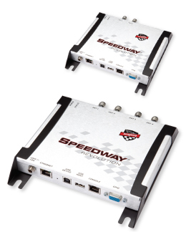

We chose Impinj for two reasons - Autopilot and POE (Power Over Ethernet). With AutoPilot, the reader tunes itself to get the best performance under changing conditions. All readers have a performance tradeoff between how many tags they can accurately read in a group, and how accurately they get the time of those reads. Speedway readers constantly adjust this balance to get the best performance.

POE means that we can power the reader with the Ethernet cable. This means one less cable to run to the reader, and additionally, since POE is relatively low-voltage (48 volts), we don’t need to worry about electrocuting anyone with a frayed extension cord.

Of course, Alien readers are fine readers, and CrossMgr supports them with CrossMgrAlien. However, Alien readers work with a static “worst-case” set of operating parameters as they cannot self tune (these parameters are sent during reader initialization). They also don’t support POE and require a separate power supply.

Besides, Speedway readers have a finish line already painted on them ;)

The reader components list was as follows:

1 - Impinj Speedway 420 RFID Reader

1 - EnGenius 802.3af PoE Injector

2 - 900mHz RFID Antennae

1 - 25' UHF Coax Cable

1 - 50' UHF Coax Cable

## Tags and Tag Mounts

We selected the “Dogbone” Monza 4 tags (available from [RMTiming](http://www.rmtimingsystems.com/)). They are designed to be read from a wide range of antenna angles, unlike the “squiggle” tags which are much more sensitive to antenna orientation. We ordered them pre-programmed with the numbers 1-500. These come as clear stickers on a roll, and each number is printed on the sticker. The price is about $0.35 each.

Metal and water interfere with tag reading, and this presents a challenge to how to mount the tag. It must be away from the metal of the bike frame and the rider’s body. The bib number worn in road racing is too close to the rider’s body and there is no number plate as in MTB. A sticker on the helmet can void the safety certification unless the sticker is “approved” (and who knows what that is?).

We came up with the following solution:

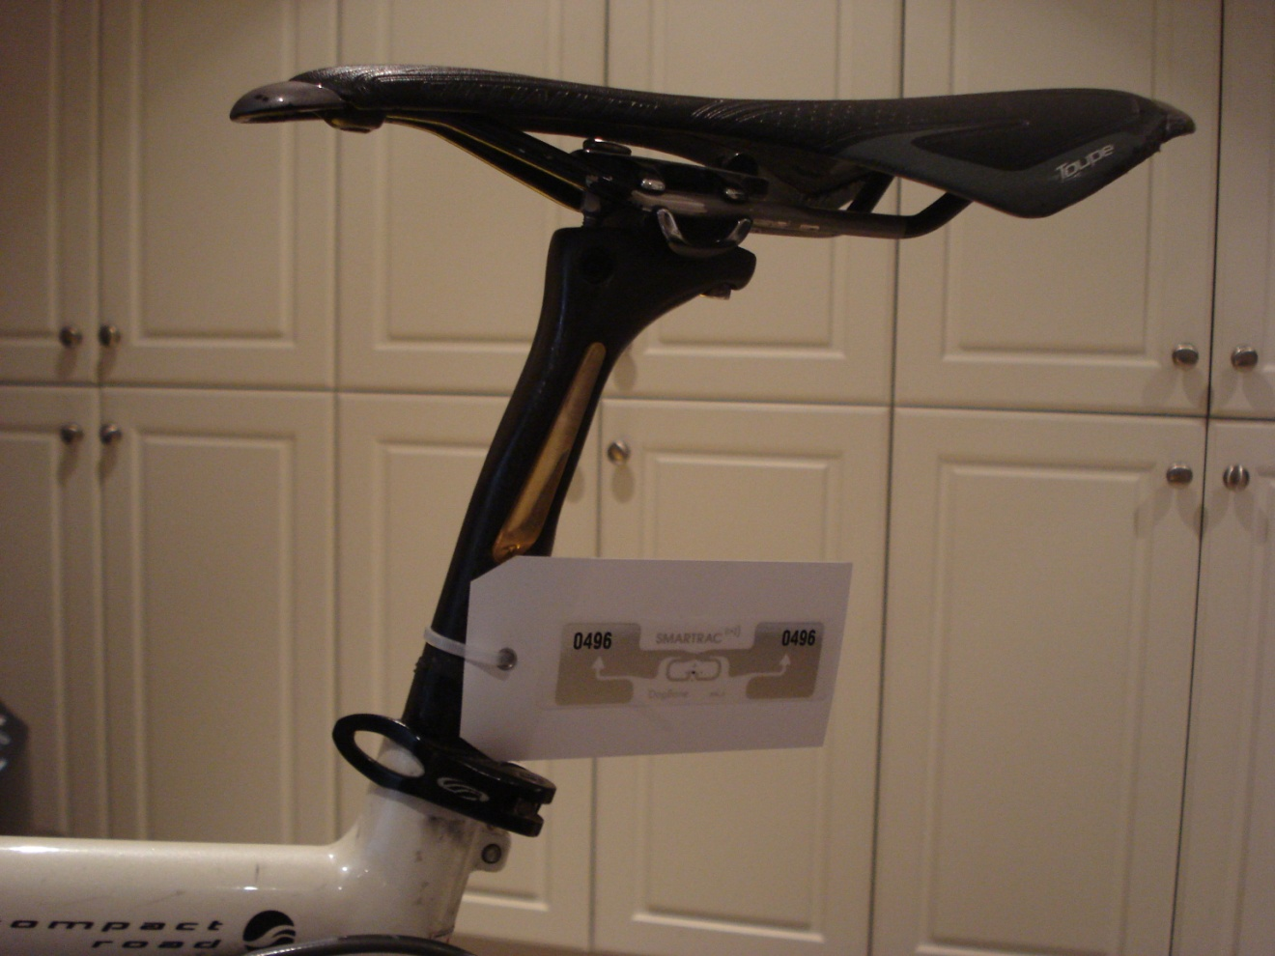

This picture shows the Monza 4 Dogbone tag, stuck on a white #5 plastic shipping tag (from ULine, see [here](http://www.uline.ca/Product/ProductDetailRootItem.Aspx?modelnumber=S-5544)), attached to the seatpost with a 5 ½” 40 lb cable tie (from [ULine](http://www.uline.com), see [here](http://www.uline.ca/Product/Detail/S-1020/Cable-Ties-and-Tools/5-1-2-40-lb-Natural-Nylon-Cable-Ties)). The cable tie is 0.14” wide, which just fits through the hole in the shipping tag (too narrow and the tag will sag, too wide and the tie won’t fit). It is important to stick the chip on the tag as far away from the hole as possible.

There just doesn’t seem to be a perfect solution for mounting the tags for road and cyclocross. It would be great to get the tags closer to the front wheel, but anything mounted on the forks gets caught in the spokes. A more rigid mount could solve that problem, but would add to the cost and weight, and is still liable to snag and break off. The total cost of chip, tag and cable tie is about $0.80, which is still disposable.

We choose white as it looks like a frame number and goes with any color scheme– we wanted the riders to feel good about putting tags on their expensive bikes!

We felt that this was a good solution that looked professional. We are now seeing some riders repurpose old bike reflector mounts to mount their tags, and they want a more removable solution than the cable tie. This is a great solution, but not disposable. In the future, we will look at trying to find a source for the reflector mounts for the riders to buy for themselves.

If anyone comes up with a better solution, please let me know! This is not a Gran Fondo ride where you could have a frame plate (that would be easy to order from rmtiming). This is for road and cyclocross racing.

## Antennas and Cables

The RF energy extends from the face of the antennas like a balloon. The fields from the antennas need to overlap for the reader to work. We decided to place the antennas on stands on each side of the finish line. This was done because it creates a good angle for reading the tags, and is more portable than an overhead structure. However, it creates the problem of getting an antenna cable safely across the road (more on that later).

The 25’ (8m) cable is quite thin, however, the 50’ (16m) cable is quite thick, about ½” (1.25 cm).

## Antenna Stands

Much thought was put into the antenna stands. The antennas are at the finish line and face each other from each side. As they are so close to the finish line, they are potential obstacles to riders in a crash, so metal or other hard objects cannot be used. We decided on the following design:

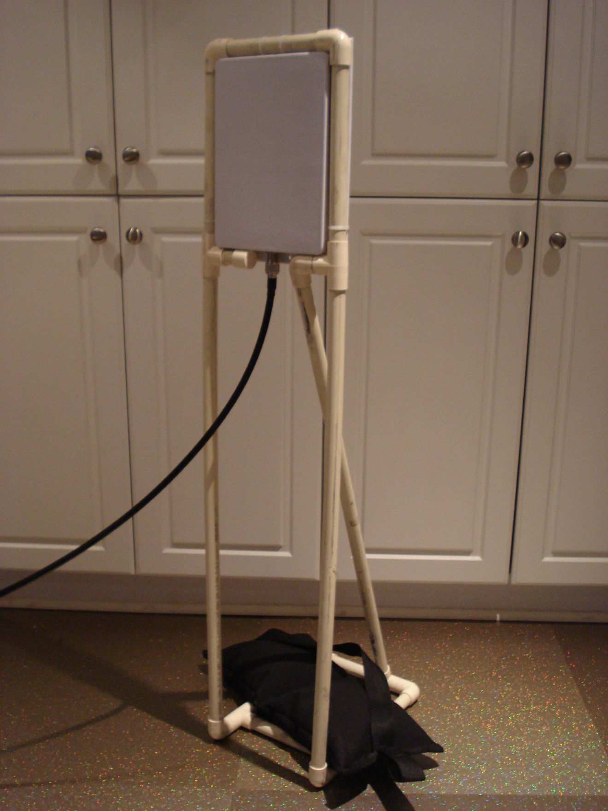

The picture shows an antenna in the stand made from ¾” plastic plumbing pipe, stabilized by a 15lb sandbag. The stand requires 7 x 90 degree bends, 5 x T connectors, one end cap, and about 15’ of plastic pipe each (you will need 30’ of pipe for two stands). Total cost was about $60 each for the pipe and end connections. The stand, without the sandbags, only weighs a few pounds, and there are no sharp edges. The net result is very stable, windproof, and does not present a serious obstacle in the event of a crash. The pipe was cut on a chop saw for accuracy. Cutting and gluing the pipes took about 2 hours.

The sandbag shown was purchased from a film supply company here in Toronto. You can improvise a sandbag from a fabric grocery bag lined with a garbage bag filled with “play sand” bought from a home store (be sure to tie off the garbage bag so it doesn’t leak).

The antenna height is such that the center of the antenna is at seatpost height. As antennas vary in size, you may have to change the dimensions to suit your requirements. The antennas are attached to the pipes with cable ties for a clean look.

## The Cable Across the Road

The antenna on the other side of the road creates the awkward problem of how to get the cable across the road.

After much thought, we decided on a black vinyl stair runner available at the home center (see [here](http://www.homedepot.ca/product/black-mat-runnr-36x50/996985)) and to run the cable under it. The runner comes 36” (1m) wide. Get an 18’ (5.5m) length piece, cut it into two 16” (40cm) strips; overlap, and duct taped the strips together to get 30’ (10m).

We then rolled it on an old 26” (66cm) long cut-down broom pole. The roll fits nicely into the “Big Box” with everything else (see below).

To deploy, unroll the runner across the road. Secure one long edge with duct tape. Stuff the cable under it. Secure the other edge of the runner with duct tape. Pull the cable tight under the runner.

Wet conditions pose a challenge as duct tape will not stick. In these circumstances, 3/4” (2cm) MDF screws can be used to secure the mat directly to the road with a battery-powered drill. This may damage the roadway – ask permission first!

The vinyl rubber does not peel up, is very stable and is even more “grippy” than the road. The only comment from the riders was that it makes a funny noise when they roll over it due to the ribs in the rubber.

Does anyone have a better solution?

## The “Toolbox”

The toolbox holds all the computer stuff that links the reader to the computer. Take a look at the pictures below:

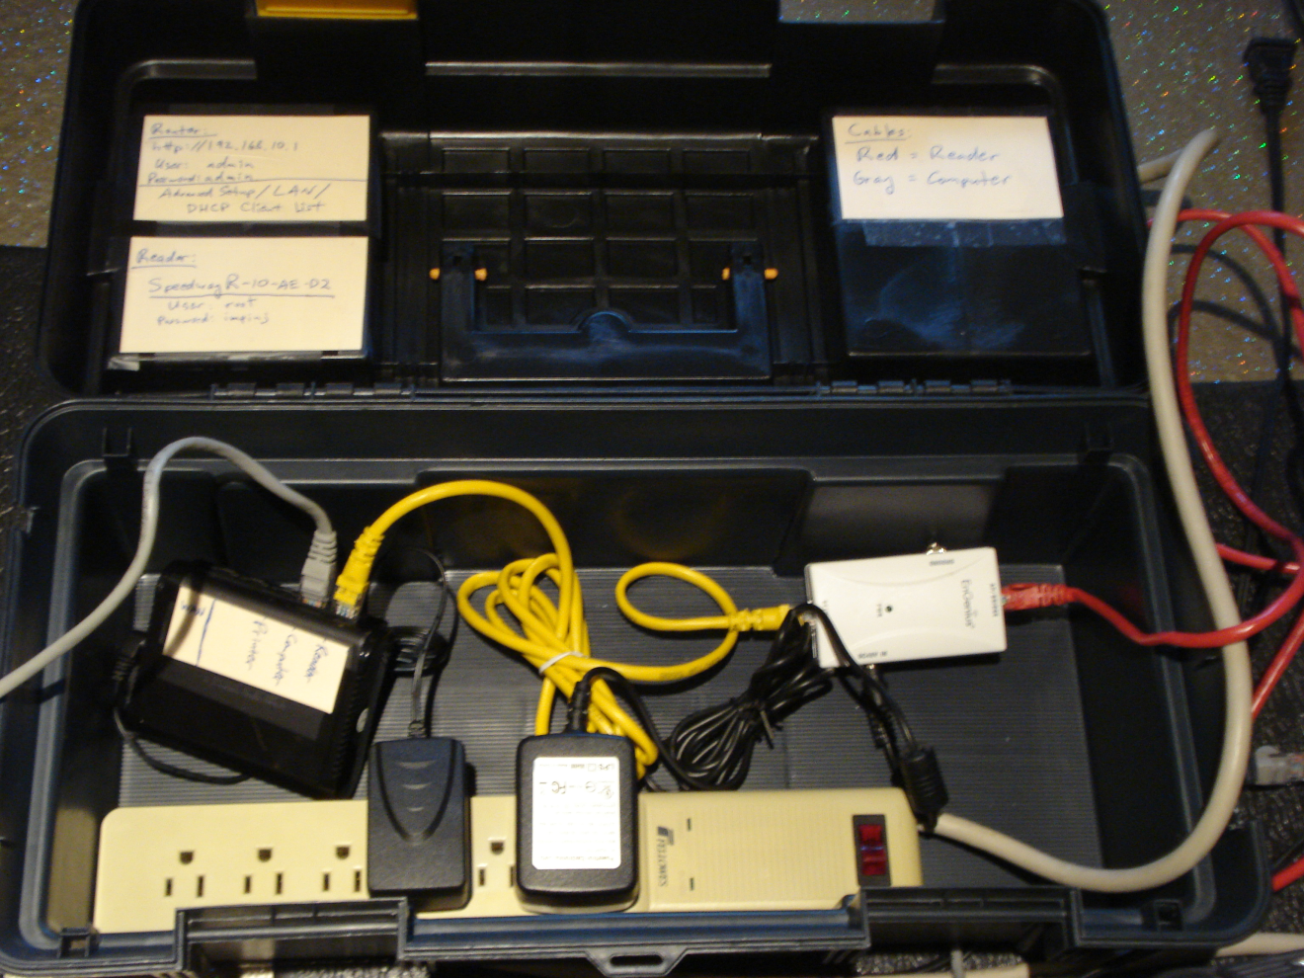

The above picture shows the Toolbox, a 26” plastic toolbox purchased at the home store (about $20). The box on the left with the Grey and Yellow cables is the router, a TrendNet Wired Router (see [here](http://www.trendnet.com/products/proddetail.asp?prod=540_TW100-S4W1CA&cat=41)). You can use any router as long as it supports DHCP.

The Grey cable goes to the computer; the Yellow cable goes to the POE injector - the white box on the right. The POE puts power into the Ethernet connection to power the reader, which connects from the red cable. This avoids having to run power to the reader. Small notches were cut in the side of the box to allow the cables to exit when the lid was closed.

At the bottom of the picture you can see the power strip and the power supplies for the router and POE. On the lid are instructions and information about the router and reader.

If you have a UPS, you want to plug this box into it. Don’t bother plugging a laptop into the UPS as it has its own internal battery.

In normal operation, the tool tray covers the components in the Toolbox and keeps them out of the way:

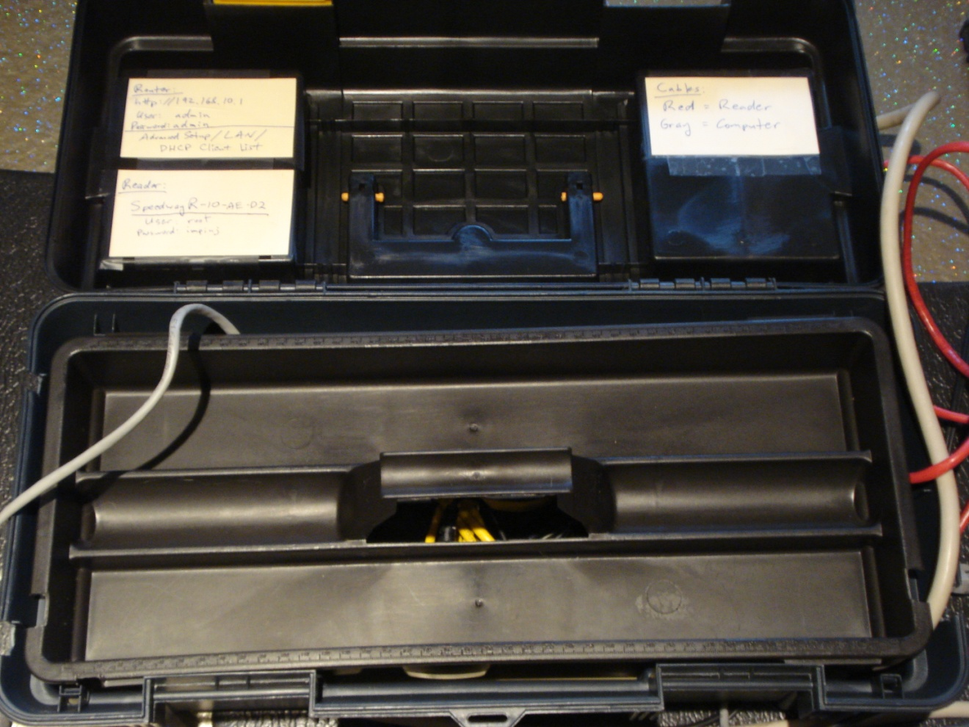

This allows all the cables to be put into the top of the box for transport.

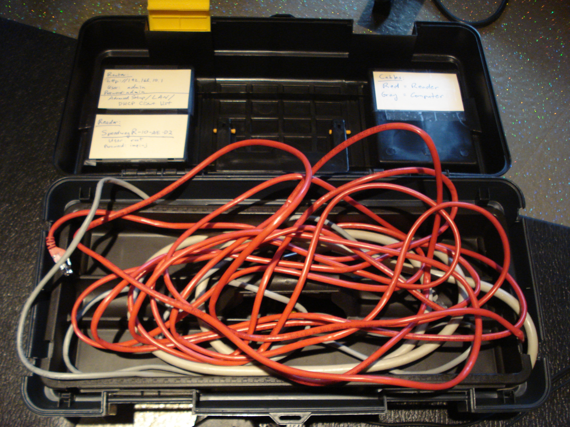

When the lid is closed, the entire package looks like this:

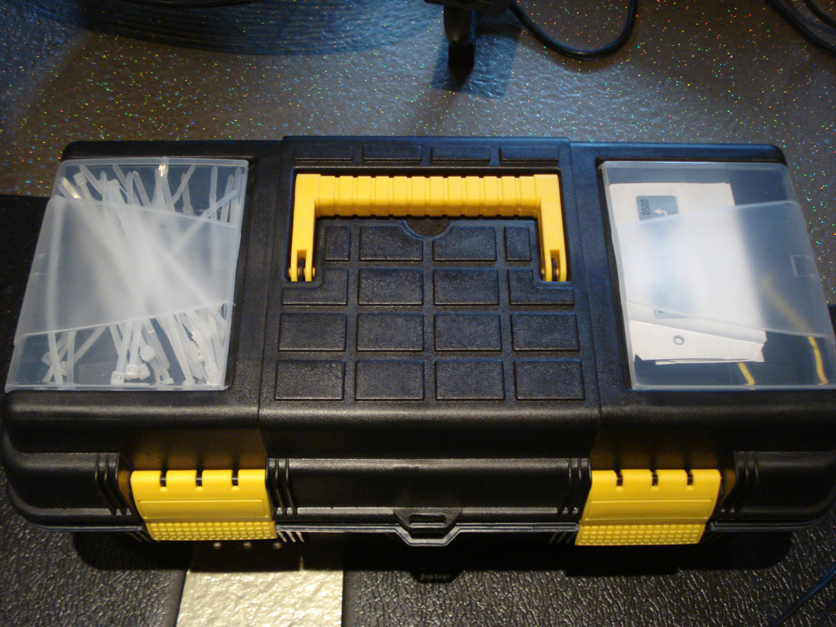

The small compartments in the lid are used for extra cable ties, spare tags, and tag clippers (just visible in the compartment on the right).

## The “Big Box”

The “Big Box” holds the cables, sandbags and Toolbox for transport. It has wheels, and is just a plastic container bought at the home store.

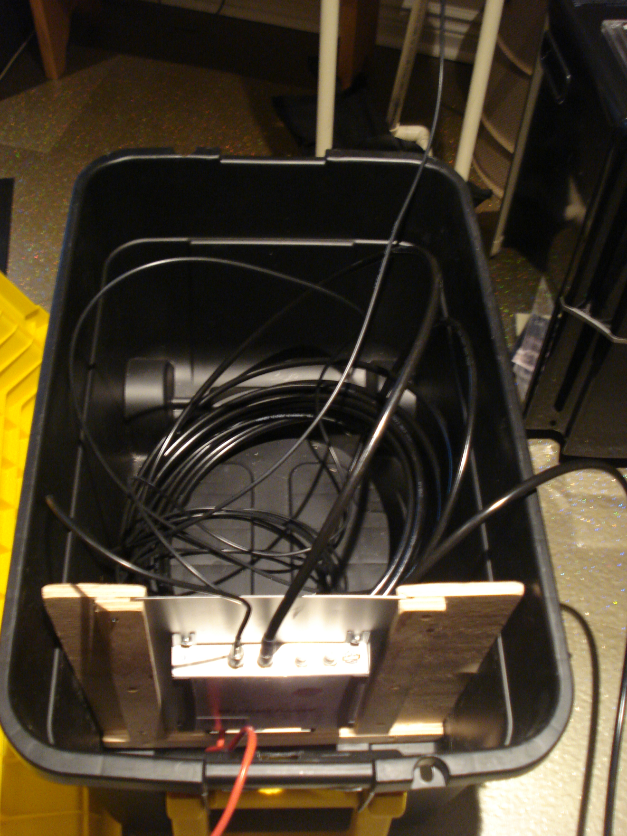

What you see here is the Big Box with the reader. Normally the big Yellow lid (seen to the left) would be on the box. The reader is mounted to a “heat sink” (a.k.a. an aluminum clipboard) that slides into a plywood frame in the box. The plywood frame is secured with some small screws through the side of the box.

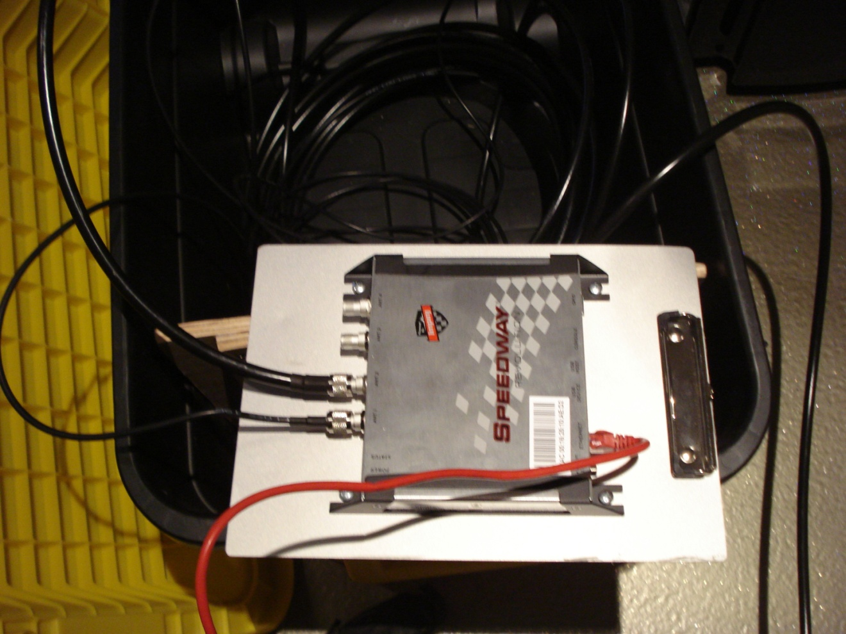

This shows the reader mounted to the “heat sink”.

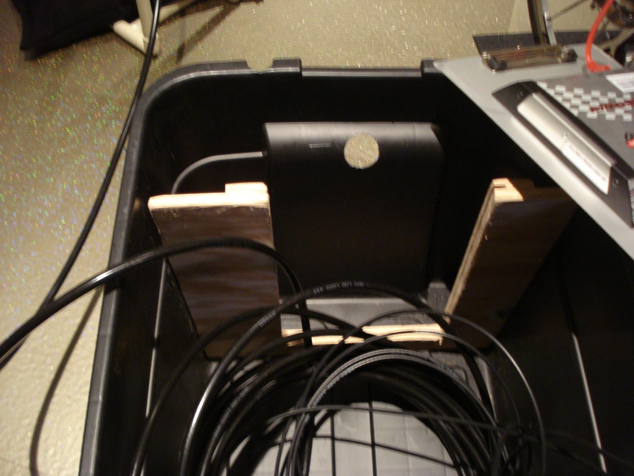

This shows the details of the plywood frame. The slots are a sawblade’s width. Also notice the hole for all the cables to leave the box. The plywood separates and protects the delicate Ethernet connections from the antennas. There is no need for a power supply to this box due to the POE.

## Hardware Setup at a Race

The hardware setup at a race is as follows:

1. Roll out the “Big Box” on its wheels to the Finish Line while carrying the antennas in your other hand (the Big Box is heavy with the sandbags in it).
2. Remove the Toolbox from the Big Box, and place it next to the table with the computer.
3. Position the antenna stands and stabilize them with the sandbags in the Big Box
4. Unreel the cables from the Big Box and connect them to the antennas. . Make sure to secure the antenna cable with duct tape if it crosses the course.
5. Plug in the Toolbox and connect it to the computer.
6. Connect the Toolbox to the reader in the Big Box. You will have to slide it out to get access to its Ethernet port.

# Software and Setup

## Installation

Install CrossMgr and CrossMgrImpinj. Get the latest versions from [here](https://www.sites.google.com/site/crossmgrsoftware/file-cabinet).

## Open the Reader Port in Windows (First time only)

Communicating with the Impinj reader requires that you **open port 5084**, otherwise the Windows Firewall will prevent the connection to the reader. You only need to do this once.

The process for opening a port depends on your version of Windows (or whatever operating system you are using).

For Windows 7, see [here](http://www.dummies.com/how-to/content/how-to-open-a-port-in-the-windows-7-firewall.html). You only need to open the port for a Private network as you will be on the wired network.. Also see this [here](http://windows.microsoft.com/en-ca/windows7/open-a-port-in-windows-firewall). In summary:

1. Open Windows Firewall by clicking the **Start** button , and then clicking **Control Panel**. In the search box, type **firewall**, and then click **Windows Firewall**.
2. In the left pane, click **Advanced settings**.  If you're prompted for an administrator password or confirmation, type the password or provide confirmation.
3. In the **Windows Firewall with Advanced Security** dialog box, in the left pane, click **Inbound Rules**, and then, in the right pane, click **New Rule**.
4. Follow the instructions in the New Inbound Rule wizard and **open port 5085**.

## Configure CrossMgrImpinj

CrossMgrImpinj forms a bridge between the CrossMgr and the reader. In addition to managing the connection, it makes a backup of all data read from the reader. This allows the race data to be “imported” to recover the results if something goes wrong during the race.

The first step is to get CrossMgrImpinj to talk to the reader.

The CrossMgr screen is divided into two sides. On the left is the connection to the reader, on the right is the connection to CrossMgr.

Make sure the computer and reader are all plugged into the Toolbox and the power is on.

1. Start CrossMgrImpinj.
2. Start a browser and connect to the router. If you have a TrendNet, type 192.168.10.1 into the browser. Login with User: admin, Passord: admin. Then choose Advanced Setup/LAN/DHCP Client List. If you do not have a TrendNet router, check your documentation for how to see the list of what is connected to it.
3. In the DHCP Client List, verify that you can see your computer and the reader. The reader will look like “SpeedwayR-XX-XX-XX” where XX-XX-XX are the first characters of its MAC address. You will also see the IP address assigned by the router (something like 192.168.10.102).
4. Press the “Auto Detect” button in CrossMgrImpinj. This will look for the reader on the router’s network. If this works, you are done.
5. In some cases “Auto Detect” does not work, or you want a more complex setup. In this case, in CrossMgrImpinj, enter the reader name as shown in the “DCHP Client List” and press “Reset”.
6. If that does not work, select “IP” and enter the reader IP address shown in the “DHCP Client List” and press Reset.

When CrossMgrImpinj connects to the reader, you will see it send command to configure the reader, then it waits for tag reads from the reader.

On the right side of CrossMgrImpinj, you will see attempts to connect to CrossMgr. We will be addressing this shortly.

For most setups, pressing the “Auto Detect” button is all you need to do on each setup.

## Test with CrossMgr

1. Make sure CrossMgrImpinj is running and has connected to the reader.
2. Start CrossMgr.
3. Select “ChipReader|J-Chip Setup”
4. Press the “Start JChip Test” button. You will be prompted about not having an Excel sheet. In a real race, you need an Excel sheet to get rider information, but for testing, we can ignore this for now.
5. You should then see the CrossMgrImpinj program immediately connecting to CrossMgr and begin to send data to it. You can see the data arrive in CrossMgr.

To learn more about how to fully configure CrossMgr including the external Excel sheet, do a help search for “Link to External Excel Data” in the CrossMgr help. For more information about how to configure CrossMgr for a chip reader, check out the help on how to configure CrossMgr for J-Chip.